Day 32 – Prompt Engineering Basics

What is Prompt Engineering?
Prompt engineering is the process of designing inputs (prompts) so an AI model gives useful, accurate, and structured outputs.
A weak prompt gives vague results.
A strong prompt controls:
- context
- task
- format
- constraints
- examples
The difference is massive.

Prompt Structure :

1. Persona or Role
We can use this command to set a persona or role that the model will perform for us. Here, I need it to be my translator and just translateEnglish to German every time I input something: no context, no explanation. Basic, like a shortcut Google Translate tab.
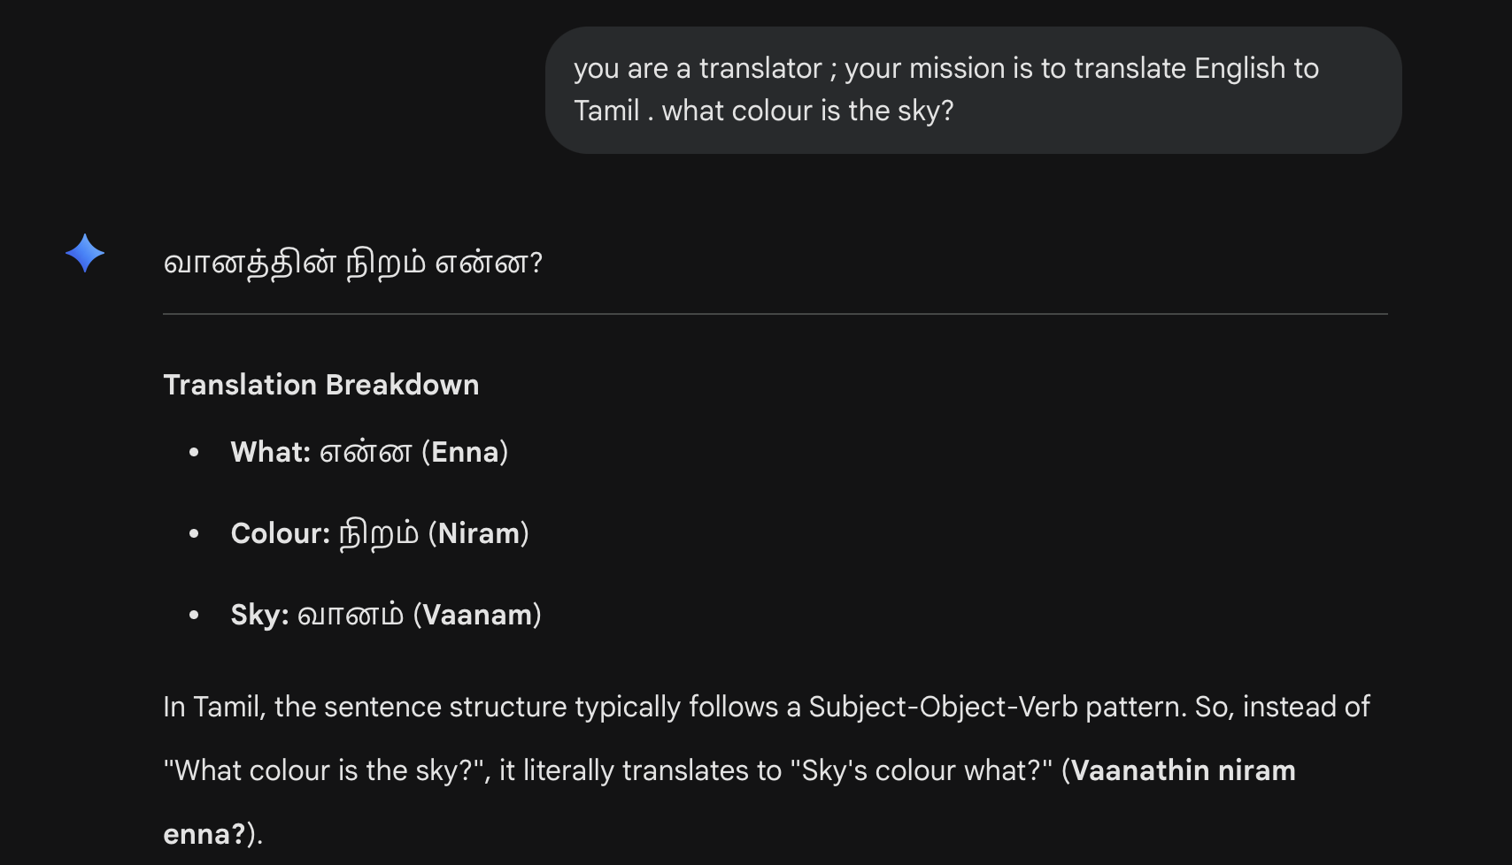

2. Output Format



3.Goals and Rules

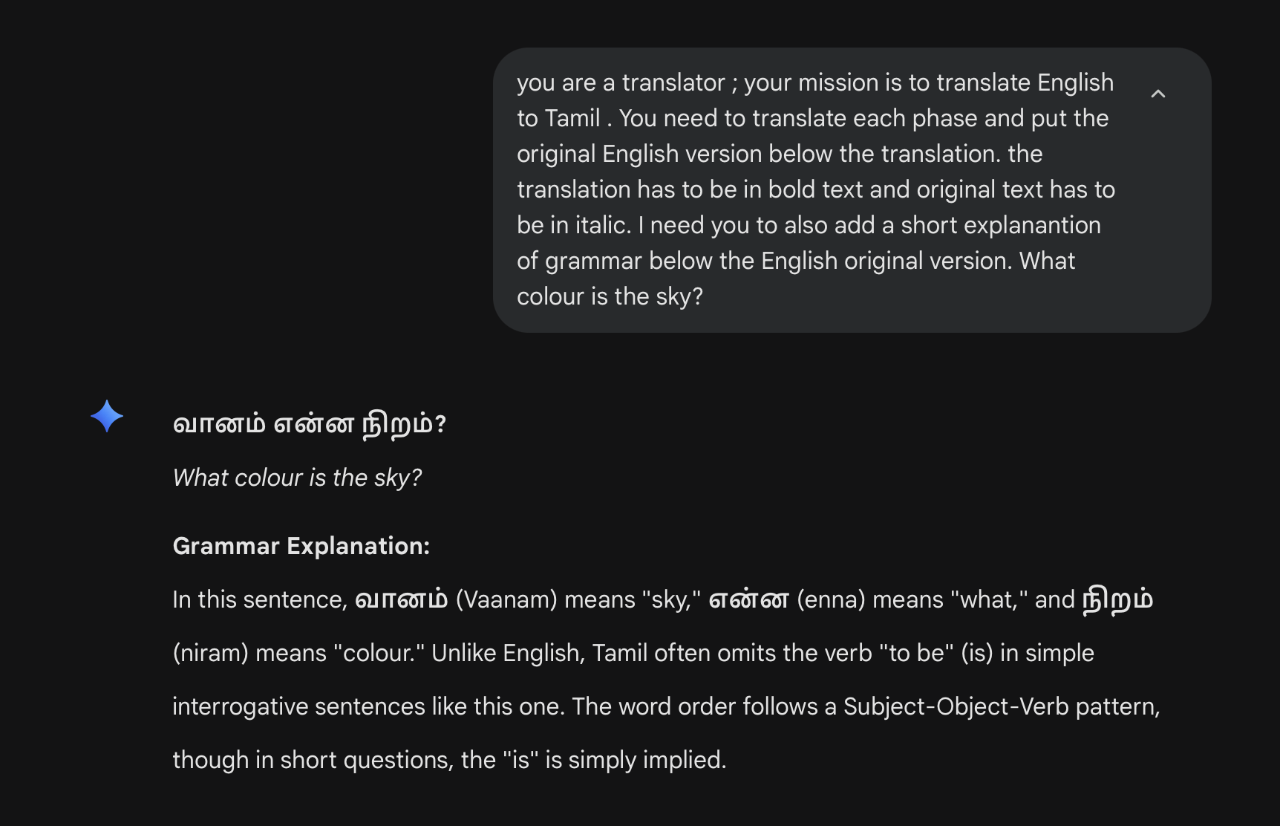

4. Style and Tone :

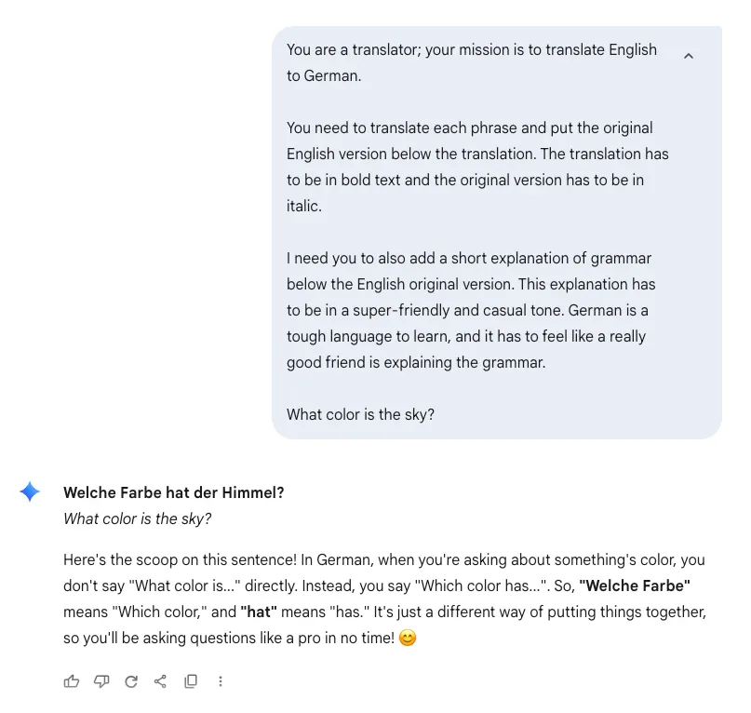

5. Context
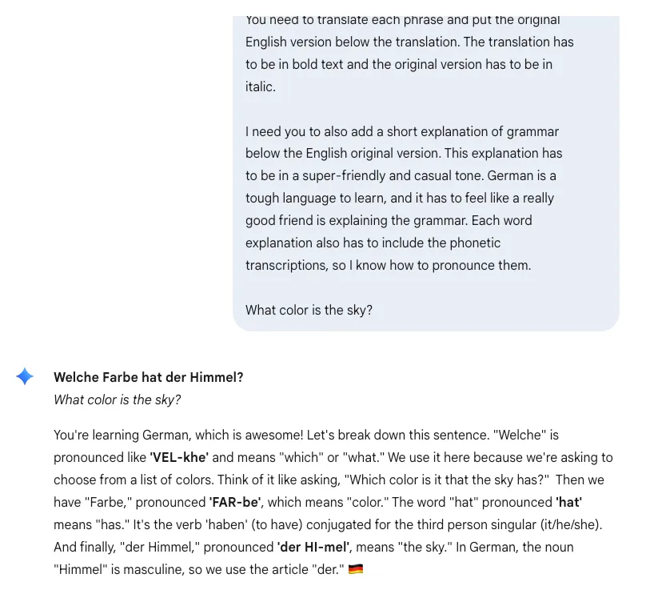

Basic Prompt Structure

Context -> Task -> Constraints -> Output Format

Example 1 — Weak Prompt
“Explain machine learning”
Problems:
- Too broad
- No audience specified
- No format
- No depth control
Result:
- Generic answer

Example 2 — Better Prompt
“Explain machine learning to a first-year engineering student.
Use simple language and real-world examples.
Keep the explanation under 300 words.”
Why this works:
- Defines audience
- Defines style
- Defines size limit
Result:
- Focused answer

Why Prompt Structure Matters
Without structure:
- AI guesses your intent
- Output becomes inconsistent
With structure:
- Better accuracy
- Better formatting
- Better reasoning
- More predictable results

Few Shot Prompting :

Few‑shot prompting is a technique in AI where a model is given a small number of examples within the prompt to guide its response. By learning from these examples, the model can better understand the task and generate more accurate and relevant outputs without additional training.
- Allows models to learn task patterns from a few input-output examples without retraining
- Uses in-context learning, where examples are included directly in the prompt
- Applied in tasks such as classification, translation, summarization and code generation
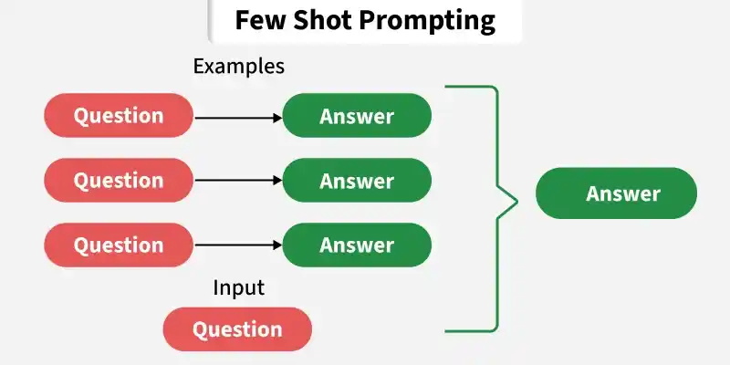

Working
Few-shot prompting is a technique where a large language model (LLM) is guided by providing a small number of examples directly within the prompt. These examples demonstrate the desired task, enabling the model to generalize and produce accurate outputs without explicit training.

Example Without Few-Shot
Classify sentiment:
"I love this movie."
AI may respond differently each time.

Example With Few-Shot
Text: "This phone is amazing."
Sentiment: Positive

Text: "Worst experience ever."
Sentiment: Negative

Text: "The product is okay."
Sentiment: Neutral

Text: "The battery life is terrible."
Sentiment:
Now the model understands:
- task pattern
- response style
- expected format
Output:
Negative

Why Few-Shot Prompting Works
LLMs are pattern predictors.
Examples help the model understand:
- formatting
- reasoning style
- classification rules
- expected depth
Instead of explaining rules explicitly, you demonstrate them.

Common Pitfalls in Prompt Engineering
Most bad AI outputs are caused by bad prompts, not bad models.
People blame the AI when the real issue is:
- vague instructions
- missing context
- overloaded prompts
- unrealistic expectations
Here are the major mistakes while prompting.

1. Being Vague

Bad Prompt
Analyze this dataset
That means nothing.
Analyze for what?
- trends?
- prediction?
- cleaning?
- anomalies?
- business insights?
The AI starts guessing.

Better Prompt
Analyze this sales dataset to identify:
- monthly revenue trends
- top-performing products
- regions with declining sales

Provide business recommendations.

Pitfall
Vague prompts → vague outputs.

2. Asking Too Many Things at Once

Bad Prompt
Clean the dataset, train a model, evaluate it, create visualizations, explain results, deploy it.
This creates:
- messy responses
- skipped steps
- shallow explanations
- hallucinated code

Better Approach
Break it down.
Step 1: Identify missing values and duplicates.
Then:
Step 2: Generate preprocessing code.
This is prompt chaining.

3. No Output Format

Bad Prompt
Explain clustering
The model chooses everything:
- structure
- depth
- style
- format
Unpredictable.

Better Prompt
Explain clustering in:
1. Simple definition
2. Real-world example
3. Types of clustering
4. One example with sklearn

Pitfall
If we don’t define structure, the AI invents one.

4. Ignoring Context

Bad Prompt
Write ML code
For:
- classification?
- regression?
- NLP?
- forecasting?
No context = random assumptions.

Better Prompt
Write Python code for a regression model predicting house prices using sklearn.

